**UNDER EMBARGO UNTIL 00:01 (GMT), 19 November 2024**

**The Missing Link: iFi Audio Unveils the GO link Max**

***Southport, UK, November 19, 2024—* iFi Audio, a trailblazer in high-fidelity audio components, proudly introduces its latest innovation: the GO link Max. The GO link Max features improvements in output power to drive demanding headphones, a balanced Dual DAC setup with a 4.4mm balanced headphone output, purer audio thanks to minimized distortion, and a more engaging and wider dynamic range.**

Looking for the perfect solution to enhance your music on the go? This ultra-portable DAC is designed to make your music sound clearer, richer, and more immersive than ever before. Whether you're a casual listener or an audiophile, the GO link Max will transform the way you hear your favorite tracks, bringing out every detail and making it feel like you're hearing them again for the very first time.

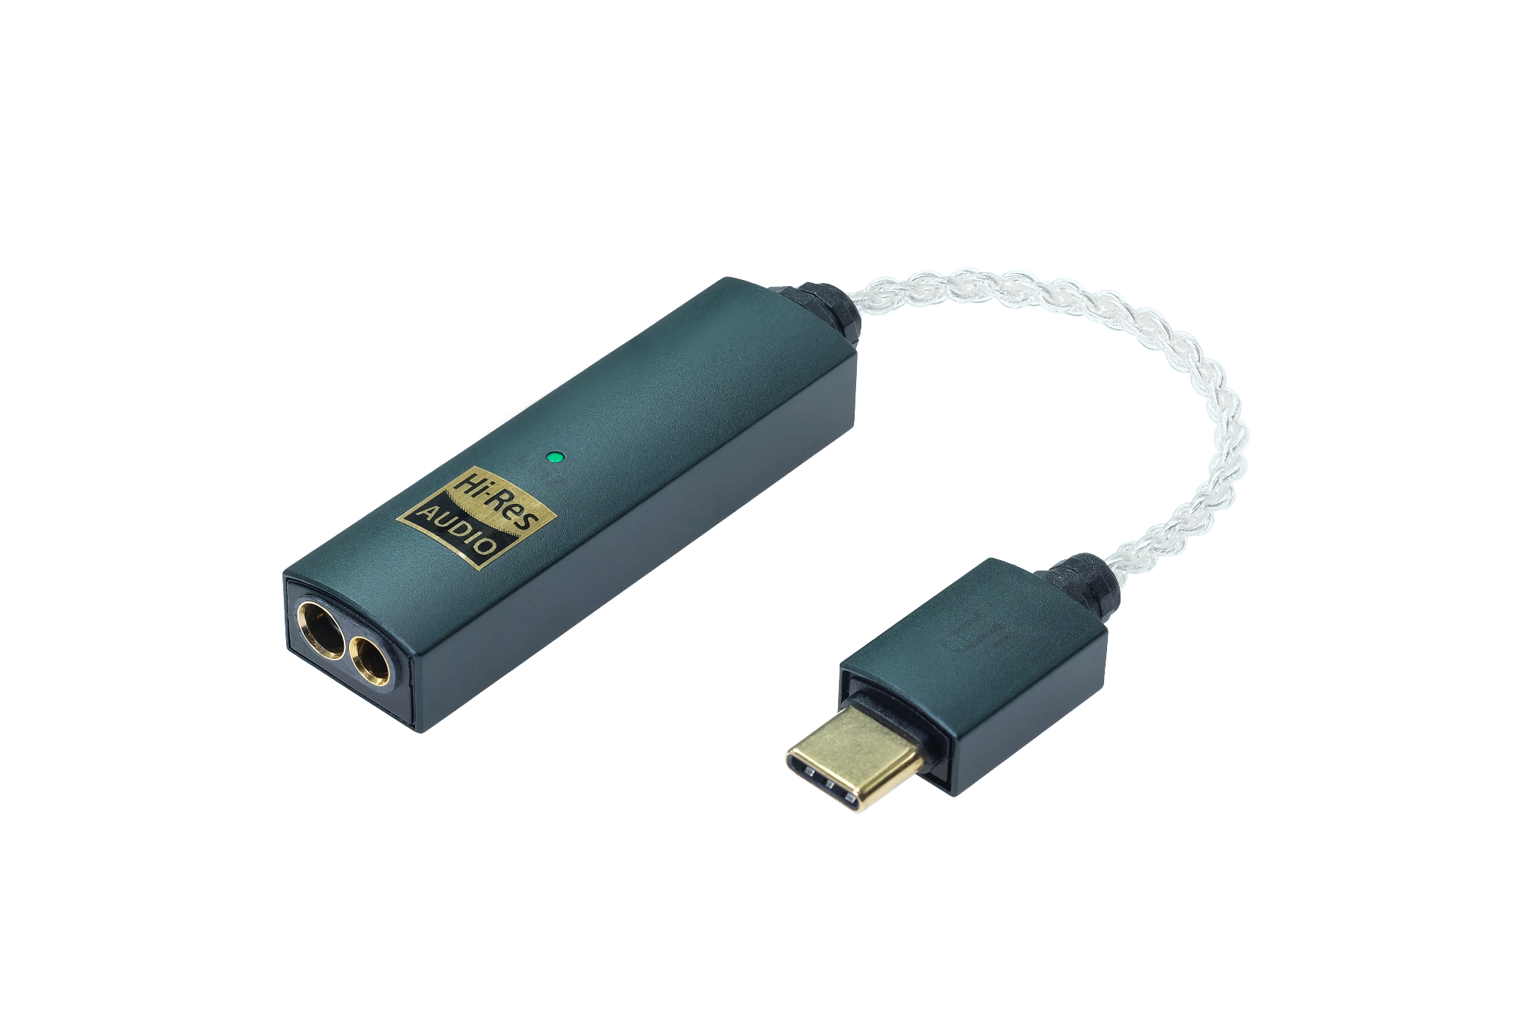

**Big Sound in a Small Package**

Despite its compact size, the GO link Max delivers a huge audio upgrade compared to its worthy predecessor. With up to 241mW of output power —nearly five times more than a MacBook Pro*— it drives demanding headphones with ease, making your music sound louder, clearer, and more powerful wherever you go.

*\*Calculated at 32 ohms RMS using MacBook Pro’s stated headphone output voltage.*

**Balanced Dual DAC for Perfect Clarity**

The GO link Max uses advanced balanced circuitry with a Dual ES9219 DAC setup, physically and audibly separating the left and right channels —with separation measuring >118dB. This separation creates an incredibly immersive experience, where instruments and vocals come to life with crystal-clear stereo positioning - it’s akin to being at a live concert, where you not only hear but ‘see’ the instruments laid out across the stage in front of you.

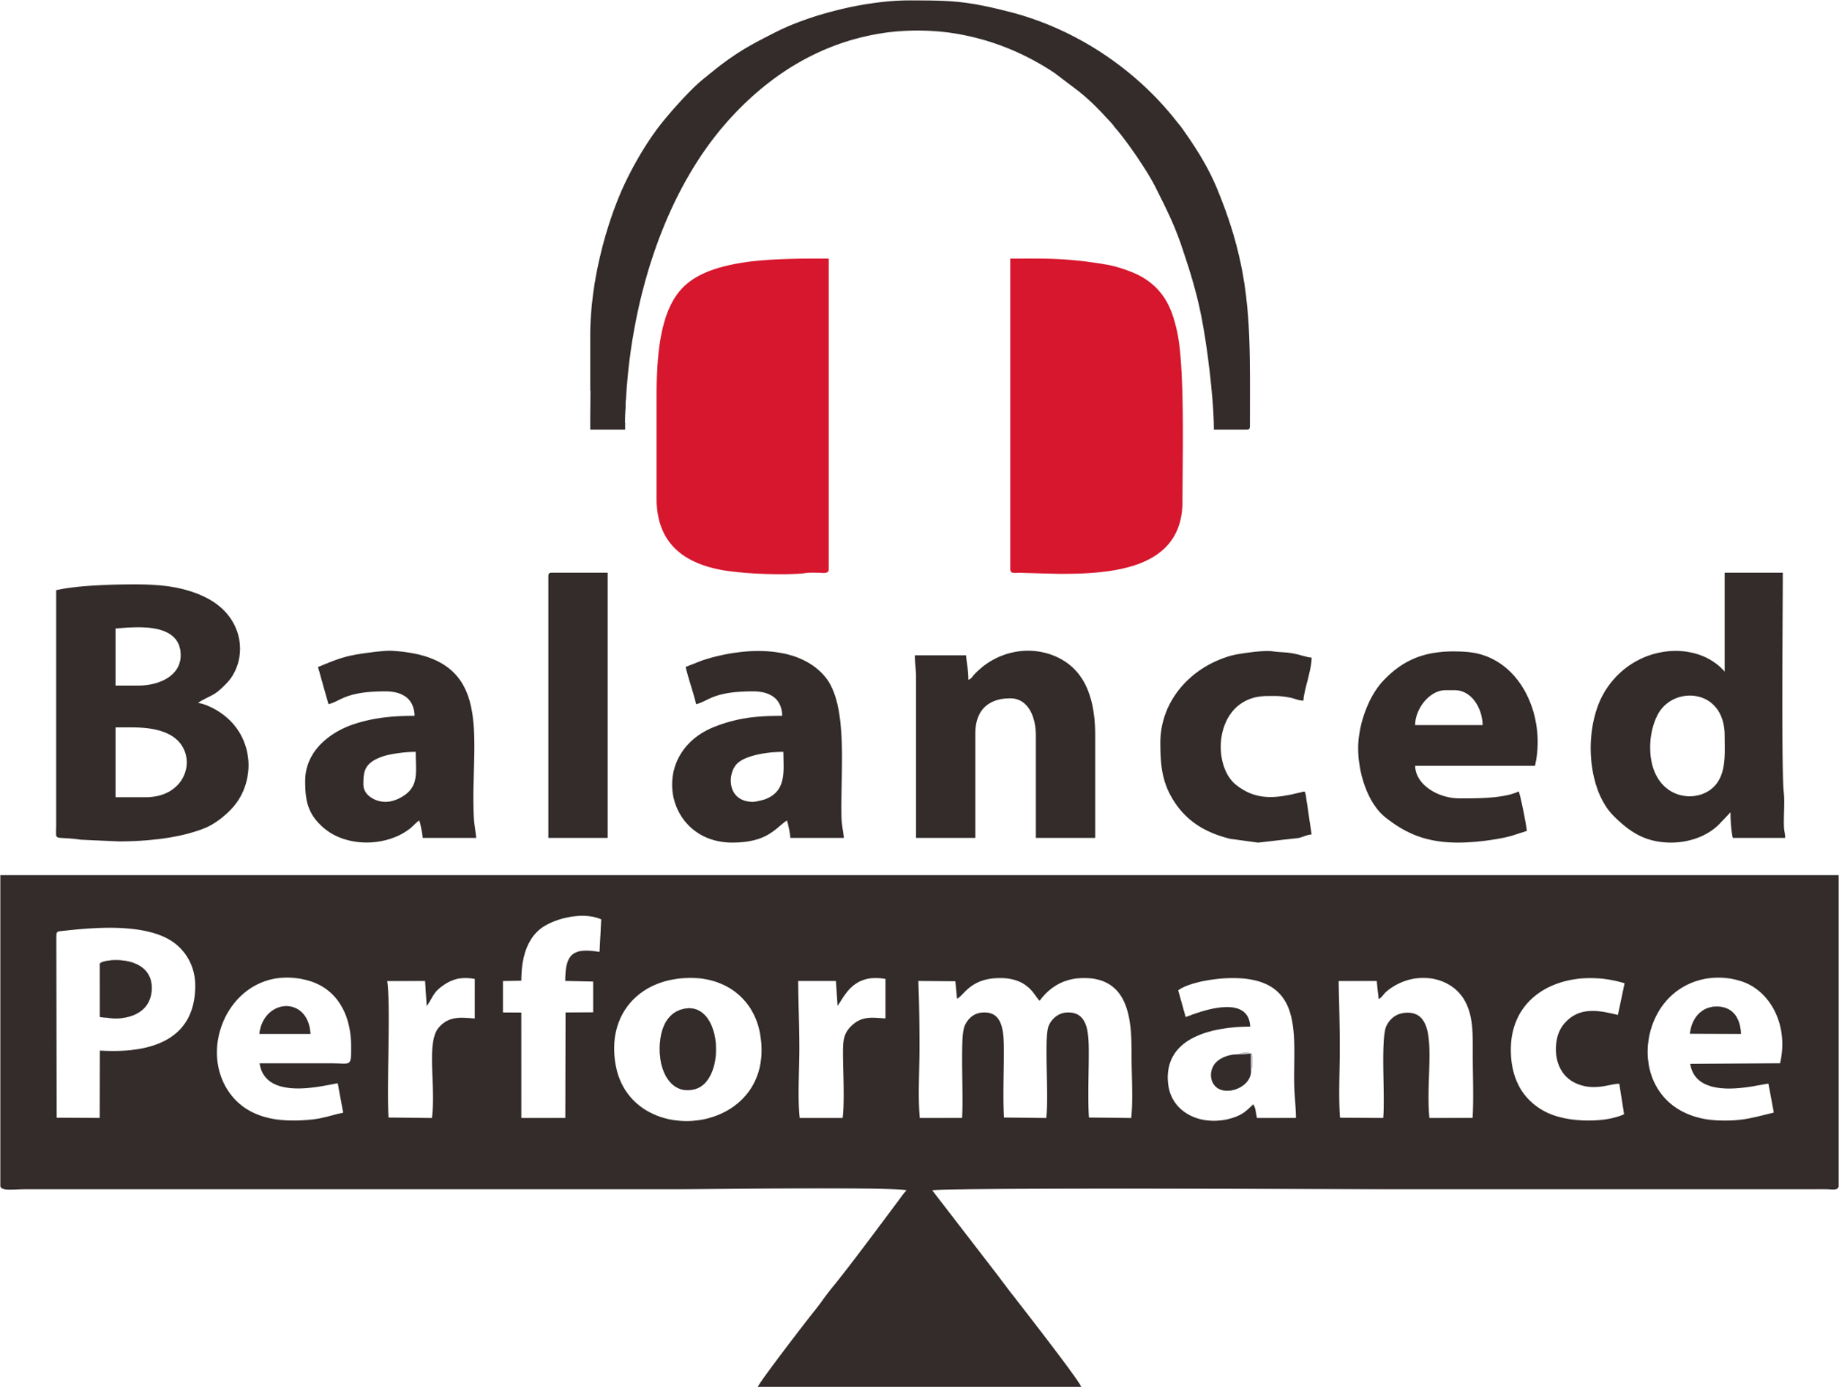

The GO link Max is built with a 4.4mm balanced headphone output to help listeners unlock the benefits of ultra-clear, precise balanced sound. With balanced audio, there is less unwanted noise or interference disrupting the signal, leaving a sound full of musicality, emotion and free from distortion.

**Next-Level Sound Quality**

With built-in cutting-edge technology to reduce distortion and deliver a purer, cleaner sound, the THD Compensation, minimizes harmonic distortion. iFi has also fine-tuned and enhanced the Dynamic Range Enhancement (DRE) to boost the range between the loudest and quietest moments, making your music experience more exciting and engaging.

**Dual DAC Precision: Crystal-Clear Audio Without Compromise**

Thanks to its advanced ‘Quad DAC+’ and Jitter Elimination technologies, the GO link Max delivers ultra-low distortion and outstanding clarity. With its silver-plated copper cable and noise-rejecting helix design, you can enjoy clear, uninterrupted sound no matter where you are.

This advanced system reduces digital noise to ensure ultra-clear sound with exceptional detail. Every note, instrument, and vocal is rendered with pinpoint accuracy, allowing listeners to experience their music with enhanced clarity and precision, free from the subtle distortions that can otherwise impact sound quality.

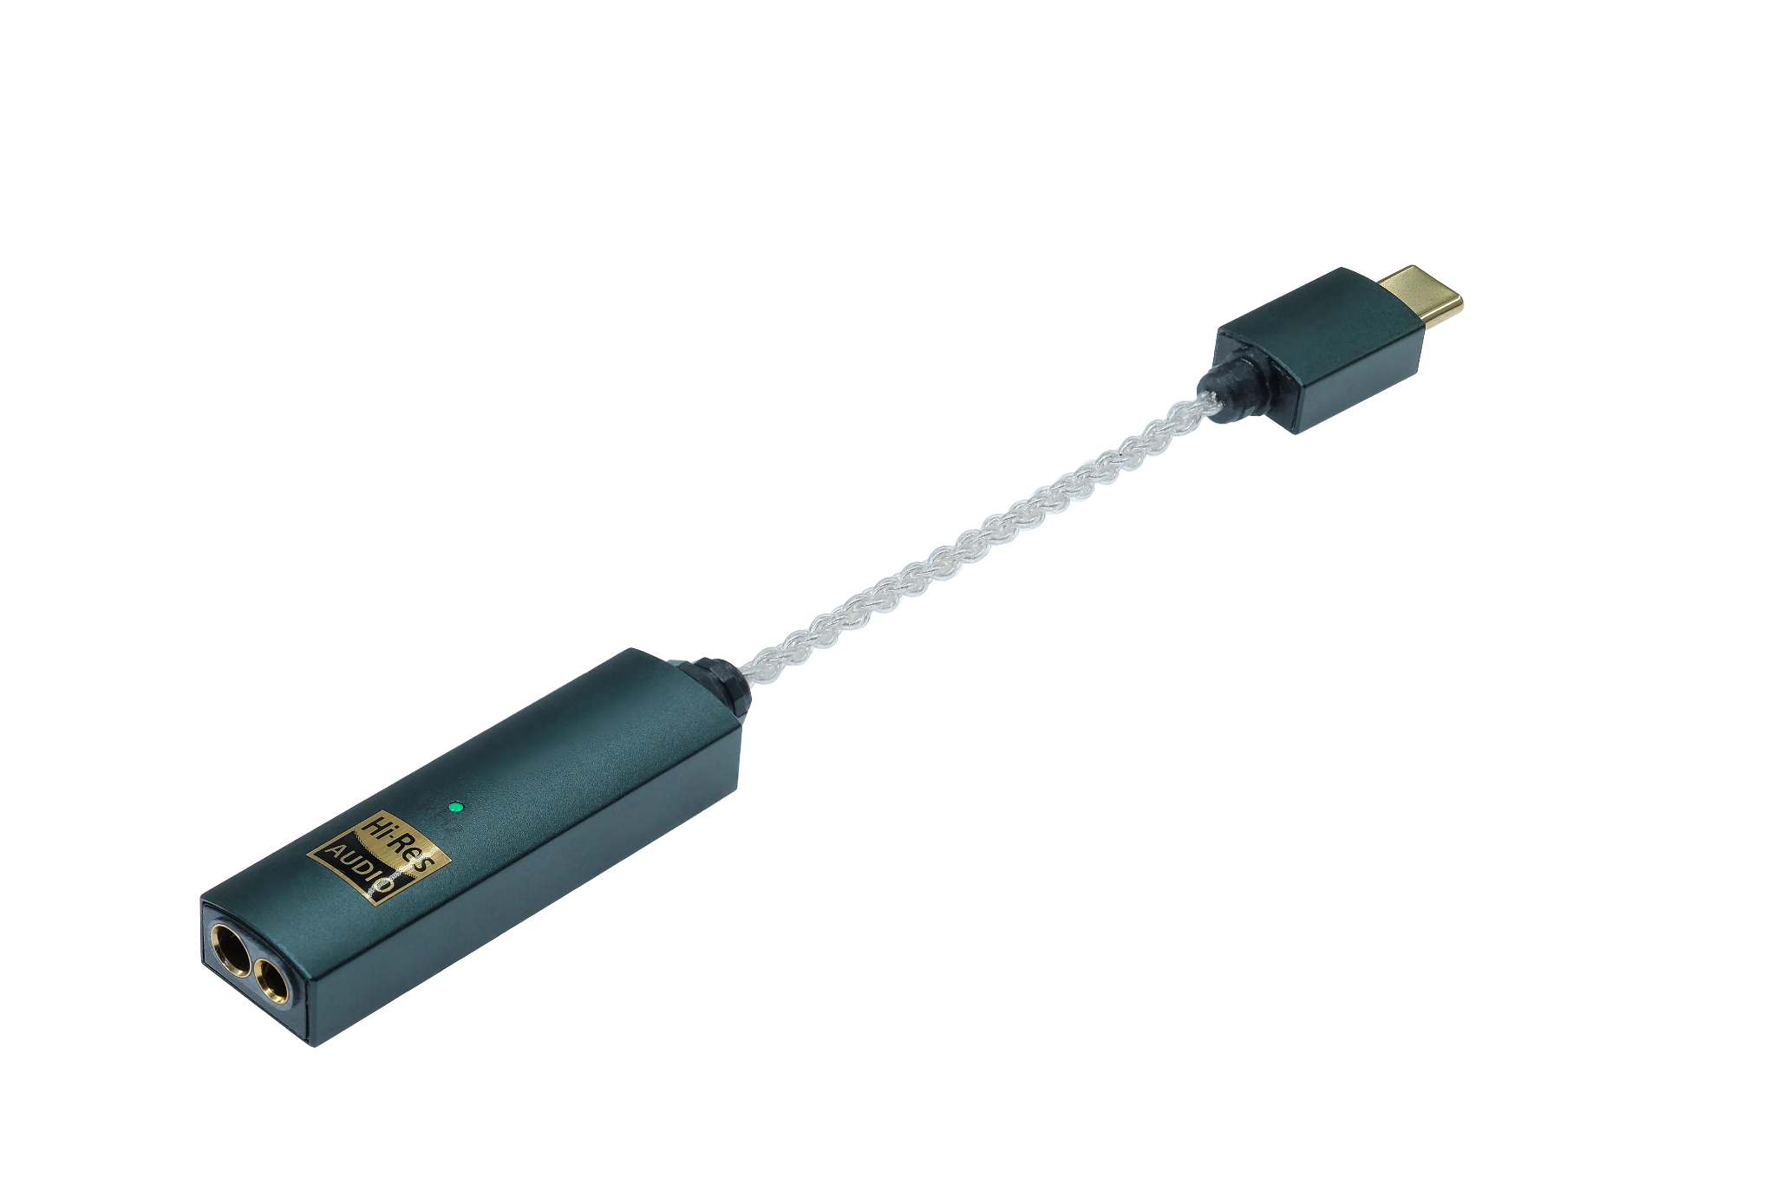

**Easy, High-Quality Volume Control**

Unlike other devices that lower sound quality when you adjust the volume, the GO link Max uses a hardware-based volume control. This means you can turn the volume up or down without losing any of the detail in your music.

**Key Features:**

* **Up to 241mW of power for louder, clearer sound:** Delivers up to 241mW of output power – nearly five times that of a standard MacBook Pro. This extra power ensures your music plays louder and clearer, even with high-end, power-hungry headphones.
* **Balanced circuitry for reduced noise and better audio separation:** Features 4.4 balanced connection to unlock balanced sound. Designed with balanced audio circuitry, this device significantly reduces noise and interference. It provides better separation between the left and right channels, giving you a more immersive listening experience with precise instrument and vocal positioning.
* **THD Compensation for purer, less distorted sound:** Advanced THD Compensation technology minimizes total harmonic distortion, giving you cleaner, purer audio. This means fewer unwanted distortions and a more accurate representation of your music.
* **Dual DAC setup with jitter elimination for precise, clear audio:** With its dual ES9219 DACs and Time Domain Jitter Elimination, it ensures incredibly precise audio conversion. This setup reduces timing errors, delivering ultra-clear sound with incredible detail.
* **Dynamic Range Enhancement for more exciting music:** Boosting the dynamic range by an additional +6dB, making the loudest moments louder and the quietest moments clearer, giving your music more depth, excitement, and emotional impact.
* **Supports hi-res audio formats like PCM 384kHz and DSD 256:** For those who appreciate high-fidelity sound, it supports hi-res audio formats like PCM 384kHz and DSD256. This ensures your music is delivered with the highest possible quality, revealing every nuance of your favorite tracks.

**GO link Max vs GO link:**

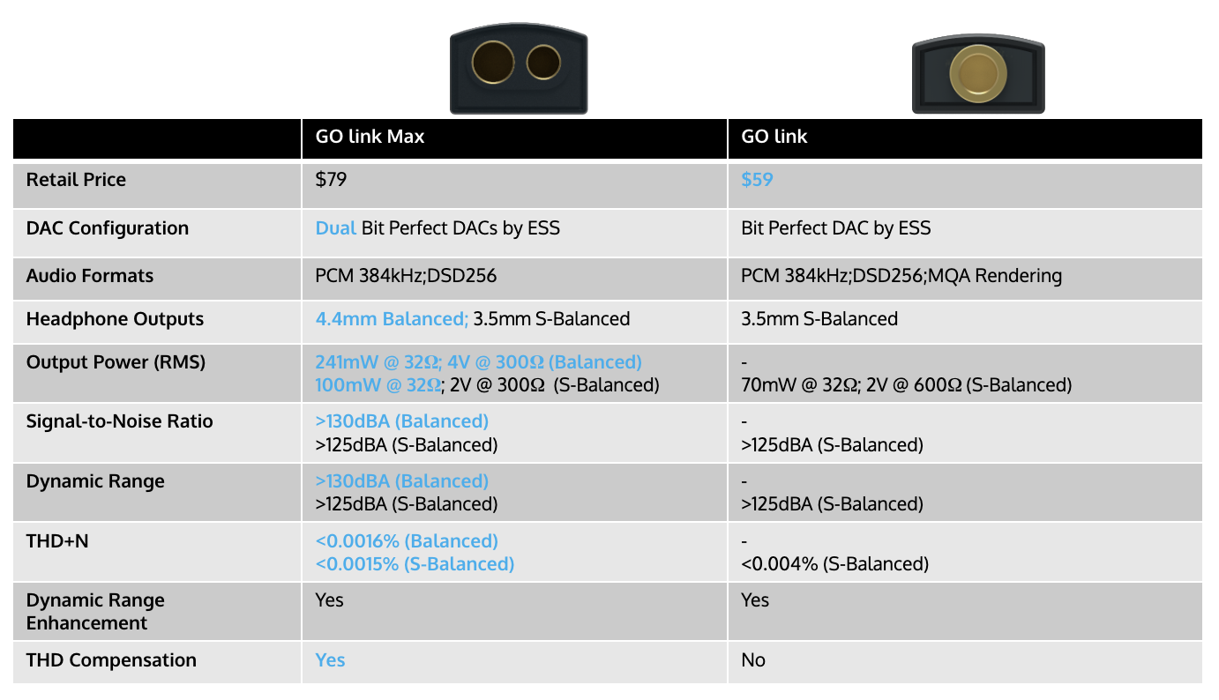

**Pricing & Availability**

The iFi GO link Max is available to purchase from ifi-audio.com and selected retailers for $79 USD/ $119 CAD.

**US Press Contact**

Hummingbird Media  
Shelby Coppola  
[shelby@hummingbirdmedia.com](mailto:shelby@hummingbirdmedia.com)

**About iFi**

iFi is the sister-brand of Abbingdon Music Research (AMR) and is headquartered in Southport, UK. The two brands respectively design and manufacture portable, desktop and lifestyle audio products and high-end hi-fi components. Combined in-house hardware and software development teams and a ‘music first’ approach enable iFi and AMR to create advanced audio products that deliver new levels of design, functionality and performance at their respective price points. Since iFi’s formation in 2012, its products have earned many awards around the world, helping it to become one of the fastest-growing brands in its field.

[www.ifi-audio.com](http://www.ifi-audio.com)

**General Specifications**

